Class Time:
Names:

The Central Limit Theorem: Central Limit Theorem Lab II

Student Learning Outcome:
- The student will examine properties of the Central Limit Theorem.
Given:
X = length of time (in days) that a cookie recipe lasted at the Olmstead Homestead. (Assume that each of the different recipes makes the same quantity of cookies.)

Recipe # | X |  | Recipe # | X |  | Recipe # | X |  | Recipe # | X
1 | 1 |  | 16 | 2 |  | 31 | 3 |  | 46 | 2
2 | 5 |  | 17 | 2 |  | 32 | 4 |  | 47 | 2
3 | 2 |  | 18 | 4 |  | 33 | 5 |  | 48 | 11
4 | 5 |  | 19 | 6 |  | 34 | 6 |  | 49 | 5
5 | 6 |  | 20 | 1 |  | 35 | 6 |  | 50 | 5
6 | 1 |  | 21 | 6 |  | 36 | 1 |  | 51 | 4
7 | 2 |  | 22 | 5 |  | 37 | 1 |  | 52 | 6
8 | 6 |  | 23 | 2 |  | 38 | 2 |  | 53 | 5
9 | 5 |  | 24 | 5 |  | 39 | 1 |  | 54 | 1
10 | 2 |  | 25 | 1 |  | 40 | 6 |  | 55 | 1
11 | 5 |  | 26 | 6 |  | 41 | 1 |  | 56 | 2
12 | 1 |  | 27 | 4 |  | 42 | 6 |  | 57 | 4
13 | 1 |  | 28 | 1 |  | 43 | 2 |  | 58 | 3
14 | 3 |  | 29 | 6 |  | 44 | 6 |  | 59 | 6
15 | 2 |  | 30 | 2 |  | 45 | 2 |  | 60 | 5

Calculate the following:
- μ_{x} = _______
- σ _{x} = _______

Collect the Data
1. Use a random number generator to randomly select 4 samples of size n = 5 from the given population. Record your samples below. Then, for each sample, calculate the mean to the nearest tenth. Record them in the spaces provided. Record the sample means for the rest of the class.
 | Sample 1 | Sample 2 | Sample 3 | Sample 4 | Sample means from other groups:
Means: | = | = | = | =

2. Calculate the following:
- = _______
- s = _______
3. Again, use a random number generator to randomly select 4 samples from the population. This time, make the samples of size n = 10 Record the samples below. As before, for each sample, calculate the mean to the nearest tenth. Record them in the spaces provided. Record the sample means for the rest of the class.

 | Sample 1 | Sample 2 | Sample 3 | Sample 4 | Sample means from other groups:
Means: | = | = | = | =

4. Calculate the following:
- = _______
- s = _______
5. For the original population, construct a histogram. Make intervals with bar width = 1 day. Sketch the graph using a ruler and pencil. Scale the axes.
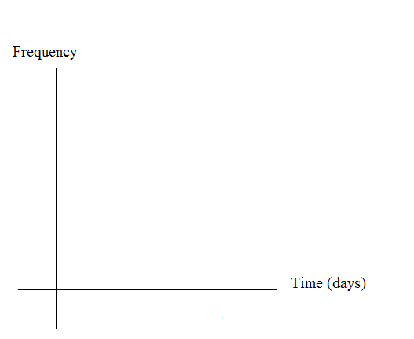
6. Draw a smooth curve through the tops of the bars of the histogram. Use 1 – 2 complete sentences to describe the general shape of the curve.

Repeat the Procedure for n = 5

1. For the sample of n = 5 days averaged together, construct a histogram of the averages (your means together with the means of the groups). Make intervals with bar widths = 1/2 day. Sketch the graph using a ruler and pencil. Scale the axes.

2. Draw a smooth curve through the tops of the bars of the histogram. Use 1 – 2 complete sentences to describe the general shape of the curve.

Repeat the Procedure for n = 10

3. For the sample of n = 10 days averaged together, construct a histogram of the averages. Make intervals with bar widths = 1/2 day. Sketch the graph using a ruler and pencil. Scale the axes.

2. Draw a smooth curve through the tops of the bars of the histogram. Use 1 – 2 complete sentences to describe the general shape of the curve.

Discussion Questions

1. Compare the three histograms you have made, the one for the population and the two for the sample means. In three to five sentences, describe the similarities and differences.

2 State the theoretical (according to the CLT) distributions for the sample means.

            - n = 5: ∼ __________
            - n = 10: ∼ __________

3. Are the sample means for n = 5 and n = 10 “close” to the theoretical mean, x? Explain why or why not.

4. Which of the two distributions of sample means has the smaller standard deviation? Why?

5. As n changed, why did the shape of the distribution of the data change? Use 1 – 2 complete sentences to explain what happened.

** This lab was designed and contributed by Carol Olmstead

